

**Tulsa’s former Black Wall Street**

**tries to remake itself**

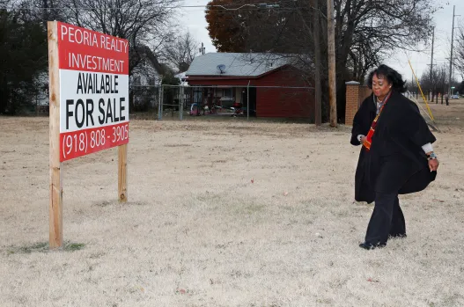

BY JUSTIN JUOZAPAVICIUS

Published 3:44 PM CDT, February 22, 2017

TULSA, Okla. (AP) — Not far from a gleaming $183 million arena and other signs of a midsize city striving to become something more, smooth pavement gives way to potholes, rusted fences and shuttered storefronts. They're the remnants of what was once known as Tulsa's Black Wall Street, before one of the worst race riots in U.S. history.

Businesses that are still open in this north-side section that some locals are adamant about reviving — the off-brand gas-and-go stores, the thrift shops and salvage yards — are often separated from the next open place by gnarled weeds, rusted fence and vacant lots.

Much of this — 35 square blocks of it — made up Black Wall Street, a southwestern Harlem of sorts and home to a middle and upper class of 9,000 African Americans. Here, shop owners, doctors and entrepreneurs — some of them freed slaves looking for a new start in the recently incorporated oil boom town — thrived.

In 1921, over the course of roughly 16 hours, a race riot decimated the economic and cultural mecca. The tally of casualties seemed more in line with the aftermath of a military battle — 300 dead, 800 wounded, more than 8,000 left homeless.

Blacks rebuilt the area in the decades that followed, only to see their work wiped out during the so-called urban progress of the 1960s.

Attempting to make good on failed hopes of an eventual renaissance, black leaders want to bring 100 businesses here by 2021, marking the race riot's 100th anniversary.

"How can we pay homage by building this community back up to what Black Wall Street was and embracing diversity?" said Reggie Ivey, who grew up in the area and is chief operating officer at the Tulsa Health Department.

Those leading the NorthTulsa100 initiative acknowledge it's an ambitious, perhaps audacious, endeavor. The project is sure to be met with difficulties, as cities around the country confront similar challenges with getting businesses to move back into African American communities, particularly poorer ones.

Leaders here are seeking manufacturers, grocery store owners and housing developers. U.S. Sen. James Lankford, among the project's higher-profile supporters, says the initiative is "not looking just for black businesses" but commercial development in general "to re-engage a community that is still scarred years later."

"North Tulsa has a stigma of being one of the worst places in town," said Donna Jackson, the project's executive director. "We don't have a grocery store; we don't have shopping."

Jackson's pitch to prospective investors is to talk up the dozens of vacant parcels they could snap up for a fraction of what they'd pay downtown, just a couple miles away.

"I don't think people know this is just sitting here," Jackson said, surveying a quarter-mile long parcel of land on a recent afternoon. "All it takes is one company — just one company."

In the early 1900s, with Tulsa and the rest of Oklahoma racially segregated, Black Wall Street was an island in a city, where residents operated their own post office, police force, school system and two newspapers. Some had modern amenities, like indoor plumbing, long before their white counterparts.

The Stradford Hotel, Dreamland Theater and Mount Zion Baptist Church were some of the more prominent social centers in the community.

In 1921, rumors of an encounter between a black man and a white woman in a downtown elevator spread, sparking anger among white residents and Ku Klux Klan members. Accounts of what happened on the elevator varied, but angry residents weren't willing to wait to sort it out. A newspaper article titled "Nab Negro for Attacking Girl in Elevator" fanned the flames.

A white mob descended on the area, looting businesses and leaving homes and churches smoldering. Leftover World War I planes that dropped bombs on the Germans just three years earlier were now employed to destroy the property of fellow Americans.

"What wasn't torched to the ground, they blew up. They blew up just about everything," says Laurel Stradford, whose great-grandfather was one of the wealthiest men in town and owned the namesake hotel destroyed in the riot.

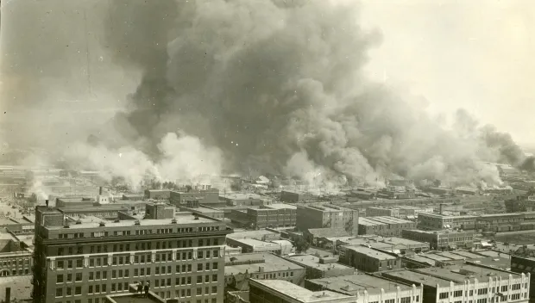

Blacks rebuilt the area in the decades that followed, only to see their work wiped out yet again, this time under the guise of urban renewal and a new highway that cut through the heart of the district.

In the 1970s and '80s, black residents who could leave fled to the suburbs. One by one, the groceries, mom and pop diners and storefronts closed. Houses were boarded up, allowing blight and crime to creep in.

Counting existing businesses that have recently opened or are under construction and commitments secured to relocate here, Jackson estimates she's 20 percent of the way to the goal, which must be met in four years.

Some businesses are warming to the idea.

Pine Place Development envisions bringing shopping, dining, a cultural museum and upscale apartments to the area.

Tim Smallwood, who opened Tropical Smoothie Cafe in 2013, also sees the potential for a rebirth. He said family members told him he was "crazy" to invest money there.

"In a lot of people's minds, you are a poor community," Smallwood said.

But his investment paid off: The cafe has seen double-digit gains.

Ralph Knight, a retired airline mechanic whose mother was 6 when the rioting began, said a turnaround could remedy some of the blight that now pocks the community and give a younger generation reason to hope — and stay — in north Tulsa.

"It's going to do something to help the black community; it's going to be something to help the kids," Knight said. "It will cut down on gang violence."

Jackson, the project director who grew up here, knows the long odds, but draws upon what was possible here nearly a century ago.

"They paved a path. What they taught us was people from anywhere can do anything," she said.

